**Industrial Visit Report**

**SRK Ladders (Strong Robust Kisan)**

**Date: 29-10-2022**

**Details Of Journey:**

**Vivekananda Polytechnic Puttur** had organized an industrial visit on **29 October, 2022** to SRK Ladders located in **Mukrampady, Puttur** for the students of Computer Science & Engineering along with faculty Rohith H P and Pramod M S.

We went by ourselves to **SRK Ladders** industry. Totally 17 Students along with 2 co-ordinators were there in the industry.

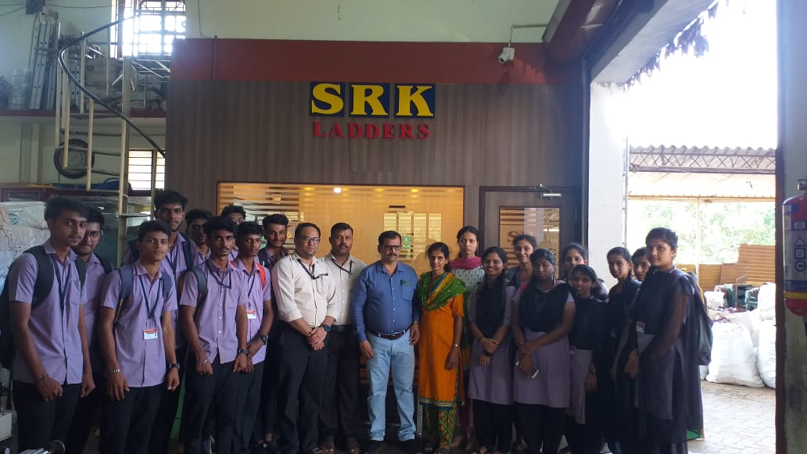

**INDEX:**

* **Details Of Journey**
* **Introduction**
* **Company Profile**
* **Group Observation**
* **Conclusion**

**Introduction**

The visit was mainly focused into understand the procedures involved during manufacture of **ladders, Hand cart, Trolley, Pepper De-coding Machine** the technology and the equipments used.

The owner of industry **Keshava A** explained about the equipments inside the industry their methods of collecting raw materials equipment used for the manufacturing of product and their storage. Accountant of industry **Prathibha** explained about software, Account, Attendance, Salary.

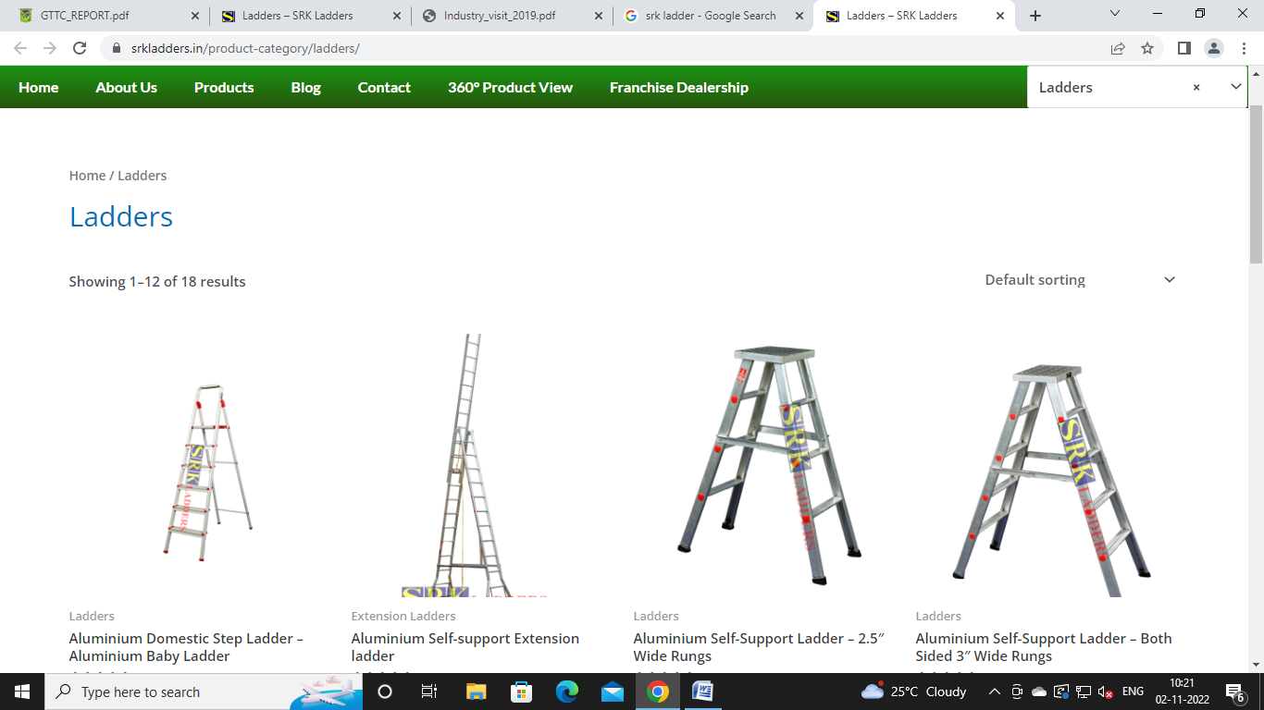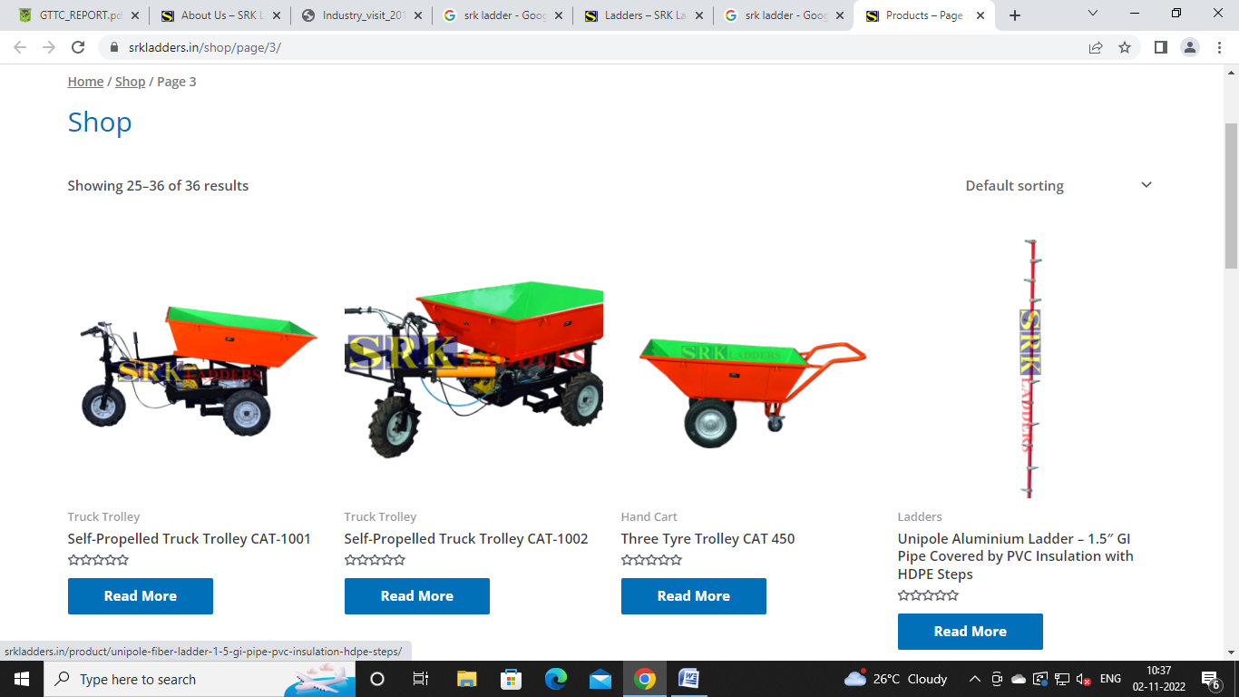

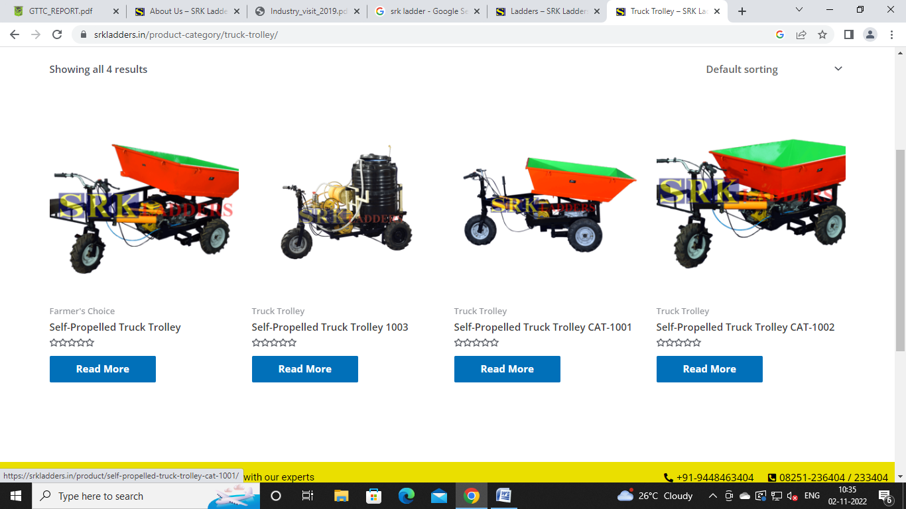

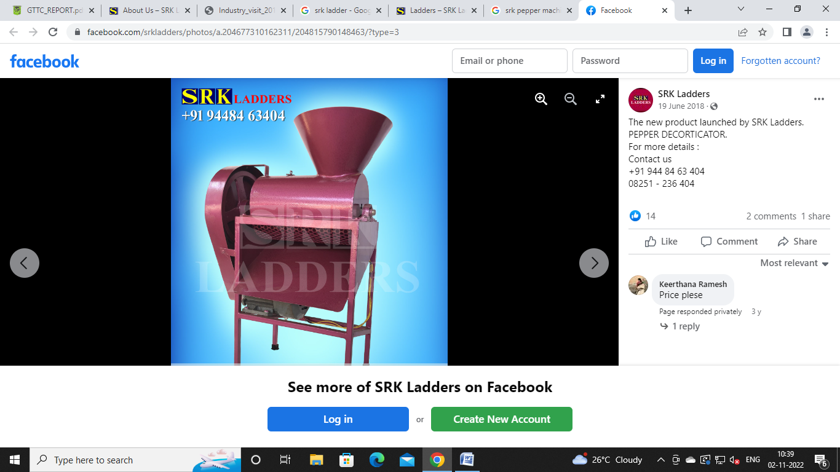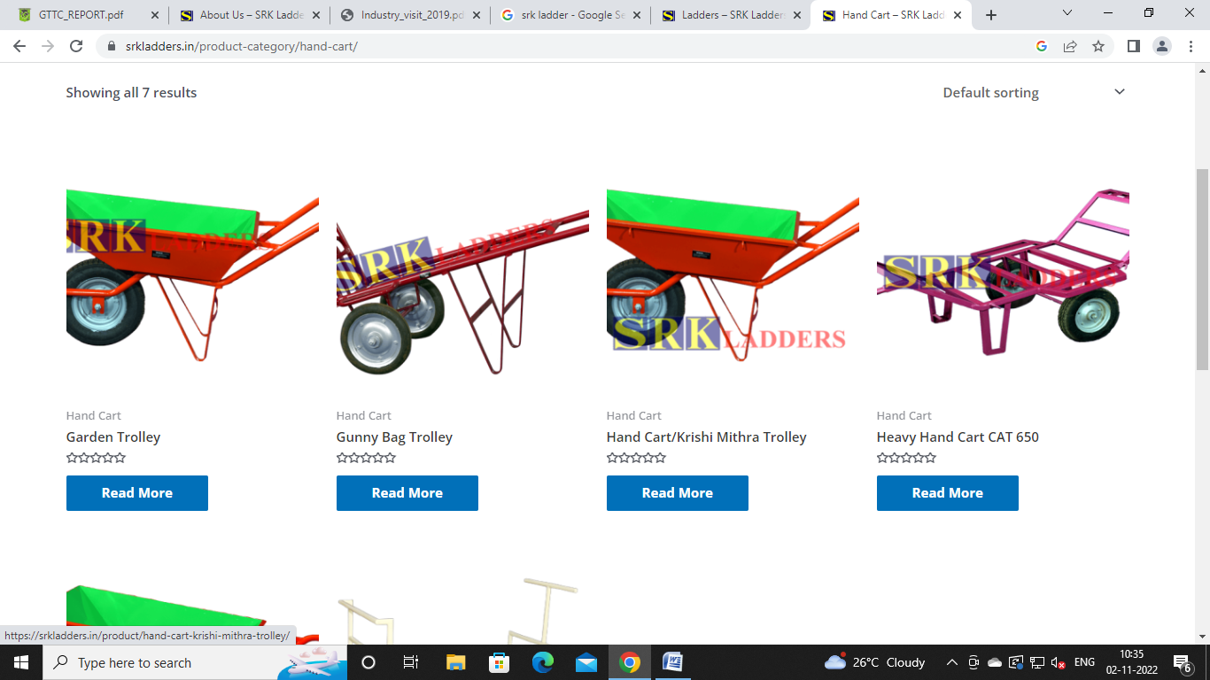

**Company Profile**

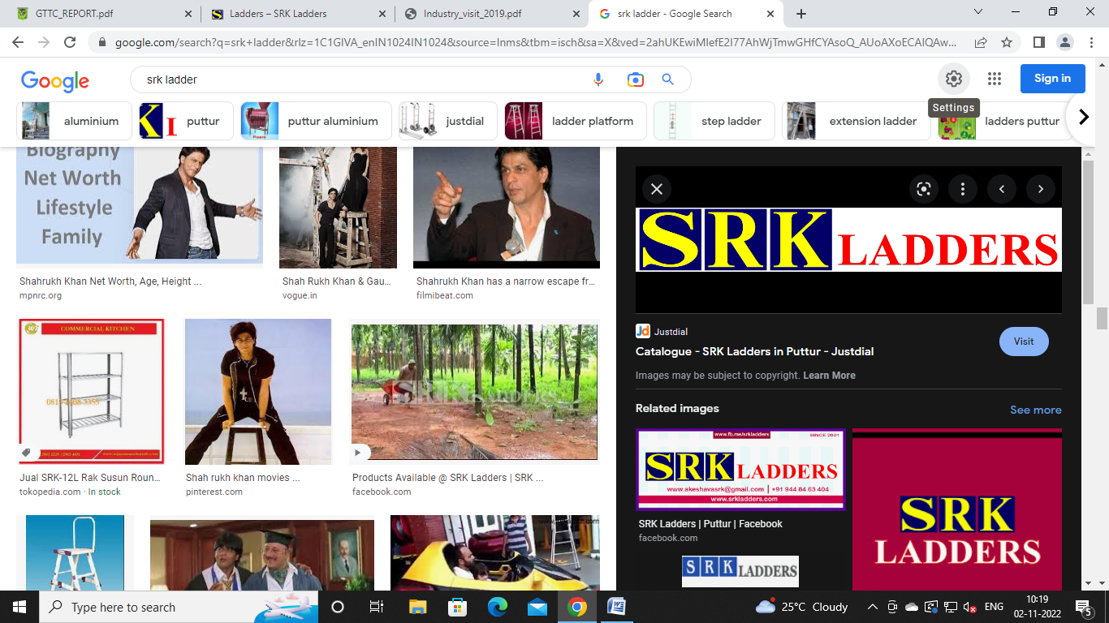

**SRK Ladders** was established in **1997** at Mukrampady Puttur.

SRK Ladders matured into one of the leading Indian manufacturer and exporter of wide variety of industrial aluminium ladders like Agricultural usage, Tree climbing ladders, Extension ladders, Maintenance ladders, Heavy machinery ladders Domestic ladders. Agri Wheel Barrow, Multipurpose Wheel Barrow Aluminum ladder.

**Group Observation**

**Departments:**

1. **Administrator:**

* Administrator manage the all product details and account management
* Administrator manages the every activity of productors and sales mans.
* Manage every employee attendance and salary
* Purchases of all commodities used as inputs in the production process and of services related to the supply of factors of production

1. **Production:**

* The industry has 3 types of production:

1. **Aluminium**
2. **Iron**
3. **Plastic**

* Store products and materials
* Ladders are manufactured by Aluminium with different sizes such as 10ft, 20ft, 12ft, 25ft, 30ft for outdoor and 5ft, 8ft for indoor.
* As height increases the quality of the ladder also increase
* Hole in the aluminium pipe is made using punching machine in ‘D’ shape, holes in both side are not parallel. They have 6mm of difference.
* Further they are sent adding process, for safety purpose edges of steps are covered by plastic caps.
* Different types of ladders are prepared. Other than ladders pepper decoding machine, trolleys.

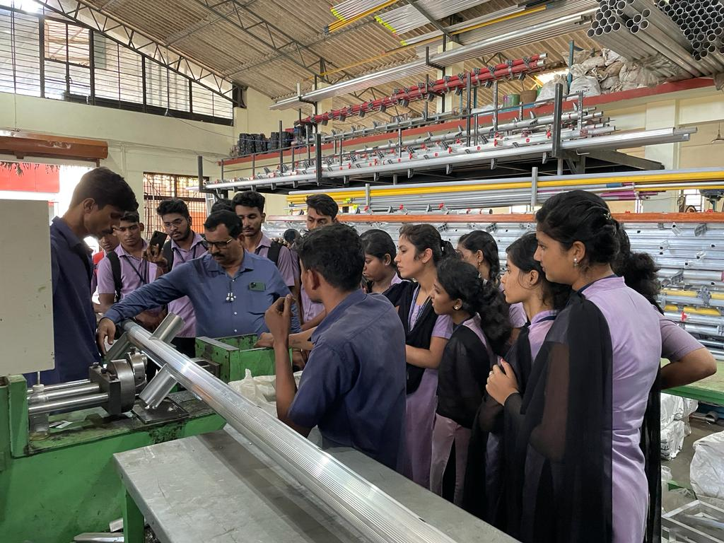

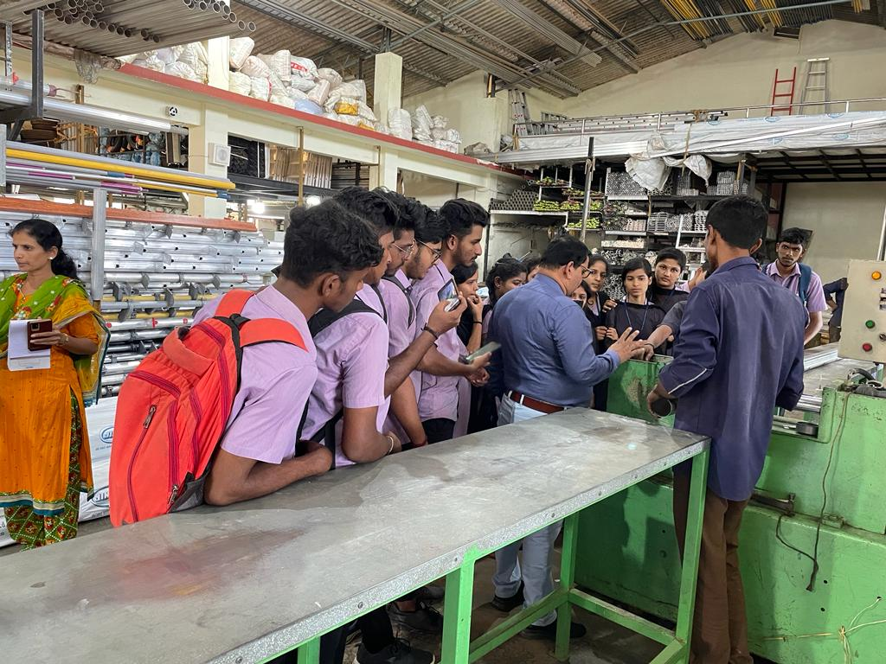

1. **Sales:**

* Deliver product to customer
* No tax for Agricultural based products
* The purchase can be done online or physical
* Sales department provides the delivery facility
* Maintain sales record
* Manages the stock loading and unloading process.
* Responsible for products or services for a company
* **0% tax** for Agriculture based products
* **18% tax** for Motor fixed trolleys, domestic and commercial ladders
* Purchase can be done via SRK official website or SRK stores.
* **SRK Stores.**
* **Kasaragod, kerala**
* **Bolwar, Puttur**
* **Mukrampady, Puttur**

**Conclusion**

We are thankful for all our faculties for organizing such an Informative event for us in crucial for development of our practical skills regarding tool & die making & other activities.

We got the knowledge on different types of activities that are held in industry.

We hope to get more chances further to have such an informative and wonderful experiences of visiting different industries.